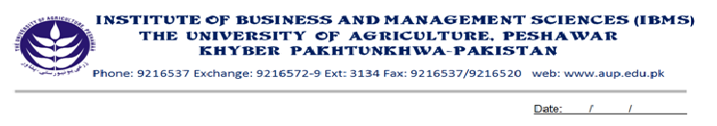
Program: BS(CS)-V
Course Name: Software Engineering-II
Course Code: CS-502
Session: 2010-2013
Credit Hours: 03
Course Week: 16
Total Hours: 48

Course Objectives
After completing this course, student will be able to understand the advance concepts of S/W engineering, the validation and verification of the soft ware, and the complexity involved in it. The students may also be able to optimize the system, and making it error free. The subject also covers the object oriented approach to S/W Engineering.

Week-1
-Object Oriented Soft ware Engineering
-Basic Concepts
-Class, Objects, Attributes, Methods
-Encapsulation, Inheritance, Polymorphism

Week-2
-Object Oriented Analysis
-The OO Process
-Use Cases

Week-3
-CRC
-Defining Structures and Hierarchies
-Defining Subsystem and Packages

Week-4
-The Object relationship model
-Object behavioral model

Week-5
-Creating UML diagrams
-Use case diagram
-Sequence diagram

Week-6
-Collaboration Diagram

Week-7
-Class Diagram
-Object Oriented Design
- The System Design Process
-Partitioning Analysis Model
-Concurrency & subsystem Allocation
-Task Management Component
-Human Computer Interface Component
-Inter Subsystem Communication
-System Design Process
-Object design process

Week-8
-The Object Design Process
-Object Description
-Designing Algorithm & Data Structure
-Programming Components & Interfaces

Week-9
-Critical Systems
- Availability & Reliability

Week-10
- Safety
- Security

Week-11
-Reliability specification
-Reliability Metrics
-Non-Functional Reliability Requirements

Week-12
-Safety Specification
-Hazard and Risk Analysis
-Fault Tree Analysis
-Risk Assessment

Week-13
-Security Specification
-Fault Minimization
-Error Avoidance

Week-14
-Fault tolerance
-Fault Detection
-Damage Assessment
-Fault Recovery

Week-15
-Verification & Validation Planning
-Soft ware Inspections
-Program Inspection
Week-16
-Defect Testing
-Black Box, Structural, Path

Total Marks: 100

Recommended Books
1. Software Engineering (Roger S. Pressman) 5th Edition
2. Software Engineering (Ian Somerville) 6th Edition

